

COMSATS UNIVERSITY ISLAMABAD
SUBJECT
INFORMATION SECURITY
PROJECT PROPOSOL
Prepared For: SIR AHMAD FARID
Prepared By: SANIA ASAD (FA24-BCS-155)

Sahiwal Campus
Department of Computer Sciences
1. Project Title
“ Product Recommendation System with Information Security Integration”

2. Introduction / Background
In modern e-commerce systems, product recommendation and data security are two of the most important features. Platforms like Amazon use Artificial Intelligence (AI) to suggest relevant products to users based on their search history and preferences.
At the same time, these systems must ensure strong Information Security (IS) to protect user data, login credentials, and system integrity.
This project combines an AI-based recommendation system with key Information Security concepts such as authentication, hashing, session management, digital signatures, and audit logging.

3. Problem Statement
Modern recommendation systems often focus only on user experience but ignore security aspects. This creates risks such as:
Key challenges include:
- Weak or unprotected user authentication systems
- Exposure of plain-text passwords
- Lack of secure session management
- No tracking of user activities (audit trail missing)
- Data integrity issues in product datasets
- No mechanism to detect unauthorized changes in system data

4. Objectives
The primary objectives of this project are:
- To develop an AI-based product recommendation system
- To implement secure user authentication using password hashing
- To ensure secure session management using unique session keys
- To maintain data integrity using digital signatures
- To implement audit logging for tracking system activities
- To integrate Information Security concepts learned in lab work into a real application
- To provide a secure and user-friendly Amazon-like system

5. Proposed Solution / Methodology
The proposed system is developed using Python and follows a hybrid approach of AI and Information Security:
🔹 Step 1: User Authentication
- Login system using username and password
- Passwords are secured using SHA-256 hashing
🔹 Step 2: Dataset Handling
- Product dataset is loaded using CSV files
- Only valid structured data is accepted
🔹 Step 3: AI Recommendation Engine
- TF-IDF vectorization is used to process product descriptions
- Cosine similarity is applied to find similar products
🔹 Step 4: Security Mechanisms
- Session keys are generated after login
- Digital signatures ensure file integrity
- Blockchain-style hashing is used for log chaining
- All activities are recorded in an audit log file
🔹 Step 5: Security Dashboard
- A GUI-based panel displays:
  - Session key
  - System logs
  - Blockchain hash status

6. Expected Outcomes / Benefits
- Secure AI-based recommendation system
- Protection of user credentials using encryption
- Improved data integrity and tamper detection
- Transparent audit system for tracking actions
- Practical implementation of IS lab concepts in real-world scenario
- Enhanced understanding of AI + Security integration

7. Tools & Technologies
The following tools and technologies are used in this project:
- Programming Language: Python
- GUI Framework: Tkinter
- Machine Learning: Scikit-learn (TF-IDF, Cosine Similarity)
- Data Handling: Pandas
- Security: Hashlib (SHA-256, MD5)
- Logging: Python Logging Module
- File Handling: CSV-based dataset system

CODE OF PROJECT:
import tkinter as tk
from tkinter import messagebox, filedialog
import pandas as pd
import hashlib
import logging
import time
import os
from sklearn.feature_extraction.text import TfidfVectorizer
from sklearn.metrics.pairwise import cosine_similarity

# ================= SECURITY BACKEND =================
logging.basicConfig(filename="security_log.txt", level=logging.INFO)

def log(event):
timestamp = time.strftime("%Y-%m-%d %H:%M:%S")
logging.info(f"{timestamp} | {event}")

def hash_password(p):
return hashlib.sha256(p.encode()).hexdigest()

def digital_signature(data):
return hashlib.md5(data.encode()).hexdigest()

# ================= GLOBALS =================
users = {"admin": hash_password("1234")}
current_user = None
products = None
sim_matrix = None
session_key = None
previous_hash = "0"

# ================= LOGIN =================
class Login(tk.Frame):
def __init__(self, master):
super().__init__(master)

tk.Label(self, text="🔐 AMAZON AI + IS SYSTEM", font=("Arial", 16)).pack(pady=10)

tk.Label(self, text="Username").pack()
self.u = tk.Entry(self)
self.u.pack()

tk.Label(self, text="Password").pack()
self.p = tk.Entry(self, show="*")
self.p.pack()

tk.Button(self, text="Login", command=self.login).pack(pady=10)

def login(self):
global current_user, session_key

u = self.u.get()
p = hash_password(self.p.get())

if u in users and users[u] == p:
current_user = u
session_key = hashlib.md5(str(time.time()).encode()).hexdigest()

log(f"LOGIN SUCCESS | {u} | SESSION:{session_key}")

messagebox.showinfo("Success", "Login Successful")
self.master.switch(Dashboard)
else:
log(f"LOGIN FAIL | {u}")
messagebox.showerror("Error", "Wrong Credentials")

# ================= DASHBOARD =================
class Dashboard(tk.Frame):
def __init__(self, master):
super().__init__(master)

tk.Label(self, text="🛒 AMAZON PRODUCT AI", font=("Arial", 16)).pack(pady=10)

tk.Button(self, text="📂 Load CSV", command=self.load_csv).pack(pady=5)

tk.Button(self, text="🔍 Recommend Products",
command=lambda: master.switch(ProductPage)).pack(pady=5)

tk.Button(self, text="🔐 Security Panel",
command=lambda: master.switch(SecurityPanel)).pack(pady=5)

tk.Button(self, text="🚪 Logout",
command=lambda: master.switch(Login)).pack(pady=5)

def load_csv(self):
global products, sim_matrix, previous_hash

file = filedialog.askopenfilename(
title="Select CSV File",
filetypes=[("CSV Files", "*.csv")]
)

if not file:
return

try:
if not os.path.exists(file):
messagebox.showerror("Error", "Invalid file")
return

products = pd.read_csv(file)

if "name" not in products.columns:
messagebox.showerror("Error", "CSV must have 'name' column")
return

if "description" not in products.columns:
products["description"] = products["name"].astype(str)

tf = TfidfVectorizer()
sim_matrix = cosine_similarity(tf.fit_transform(products["description"]))

# Blockchain-style chaining
current_hash = digital_signature(file + previous_hash)
previous_hash = current_hash

log(f"CSV LOADED | {file} | HASH:{current_hash}")

messagebox.showinfo("Success", "CSV Loaded Successfully")

except Exception as e:
log(f"CSV ERROR | {str(e)}")
messagebox.showerror("Error", str(e))

# ================= PRODUCT PAGE =================
class ProductPage(tk.Frame):
def __init__(self, master):
super().__init__(master)

tk.Label(self, text="🤖 PRODUCT RECOMMENDER", font=("Arial", 14)).pack()

self.e = tk.Entry(self, width=40)
self.e.pack(pady=10)

tk.Button(self, text="Recommend", command=self.recommend).pack()

self.listbox = tk.Listbox(self, width=60)
self.listbox.pack(pady=10)

tk.Button(self, text="⬅ Back",
command=lambda: master.switch(Dashboard)).pack()

def recommend(self):
global products, sim_matrix

if products is None:
messagebox.showerror("Error", "Load CSV first")
return

q = self.e.get().lower()

match = products[products["name"].str.lower().str.contains(q)]

if match.empty:
messagebox.showerror("Error", "Not found")
return

idx = match.index[0]

scores = sorted(list(enumerate(sim_matrix[idx])),
key=lambda x: x[1],
reverse=True)

self.listbox.delete(0, tk.END)

for i in scores[1:6]:
self.listbox.insert(tk.END, products.iloc[i[0]]["name"])

log(f"SEARCH | {q}")

# ================= SECURITY PANEL (VISIBLE IS) =================
class SecurityPanel(tk.Frame):
def __init__(self, master):
super().__init__(master)

tk.Label(self, text="🔐 SECURITY DASHBOARD", font=("Arial", 16)).pack(pady=10)

tk.Label(self, text=f"Session Key:\n{session_key}").pack(pady=5)

tk.Label(self, text=f"Blockchain Hash:\n{previous_hash}").pack(pady=5)

tk.Button(self, text="📜 View Logs", command=self.show_logs).pack(pady=10)

tk.Button(self, text="⬅ Back",
command=lambda: master.switch(Dashboard)).pack()

def show_logs(self):
try:
with open("security_log.txt", "r") as f:
data = f.read()

win = tk.Toplevel(self)
win.title("Security Logs")

text = tk.Text(win, width=80, height=25)
text.pack()
text.insert(tk.END, data)

except:
messagebox.showerror("Error", "No logs found")

# ================= MAIN APP =================
class App(tk.Tk):
def __init__(self):
super().__init__()
self.title("Amazon AI + Full IS Project")
self.geometry("600x500")
self.page = None
self.switch(Login)

def switch(self, frame):
if self.page:
self.page.destroy()
self.page = frame(self)
self.page.pack()

# ================= RUN =================
App().mainloop()

OUTPUT OF MY PROJECT:
LOGIN DASHBOARD:

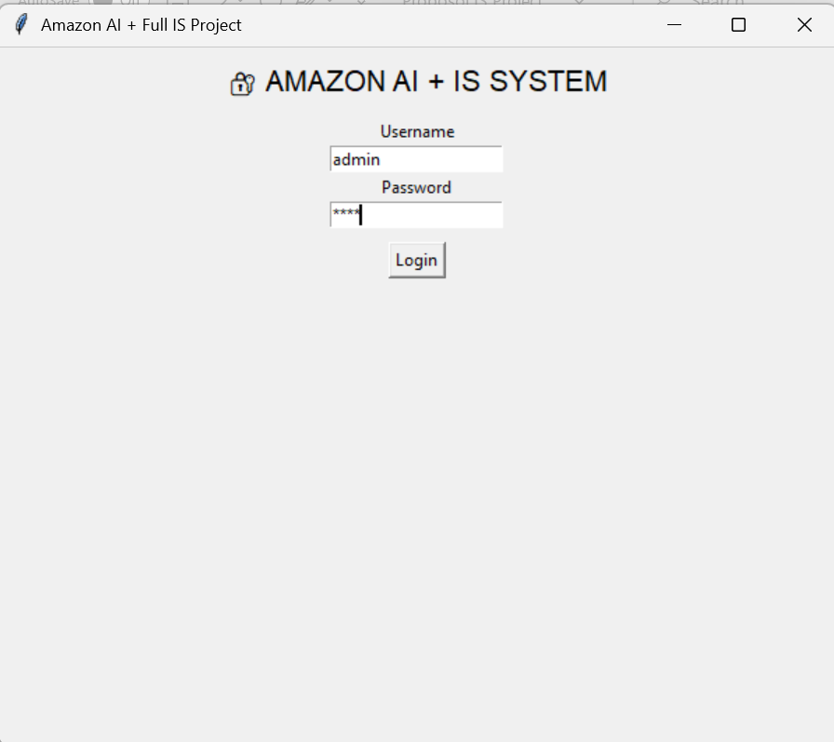

LOGIN SUCCESSFULLY:
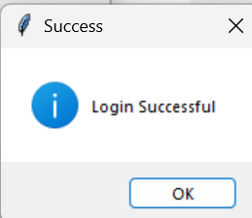

MAIN PAGE;

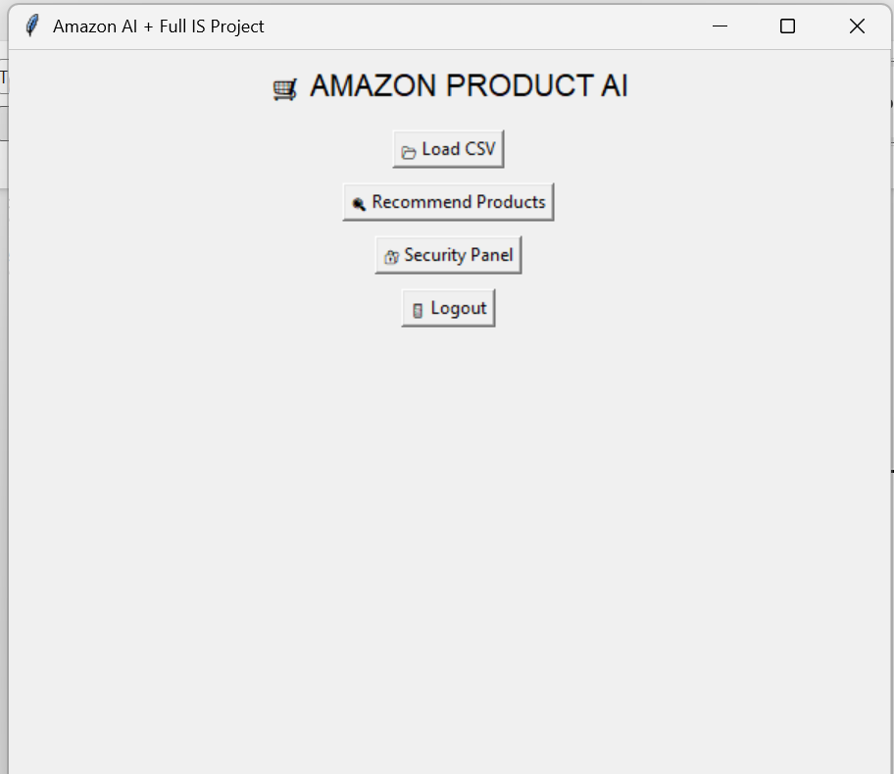
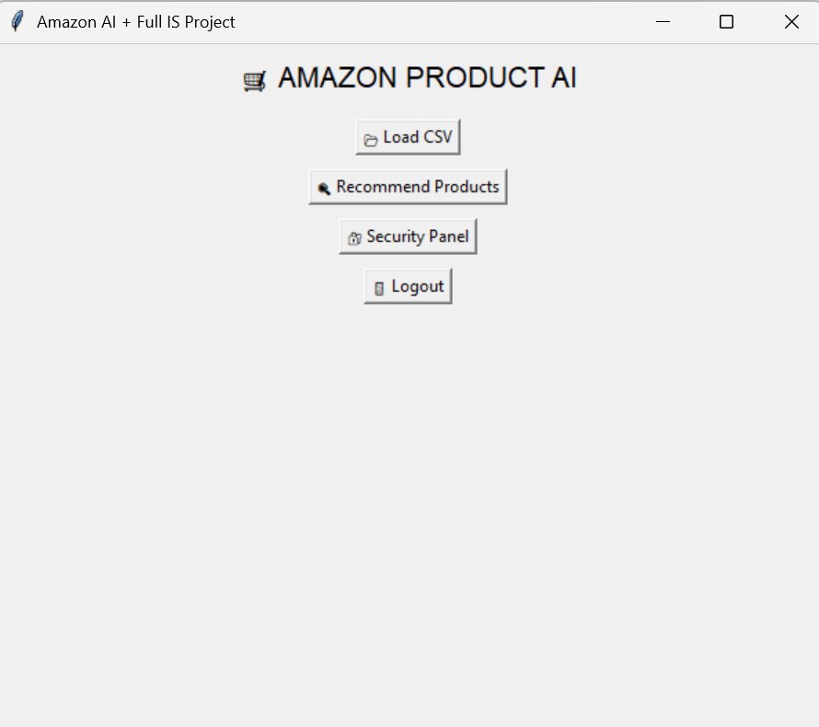
CLICK LOAD CSV FILE: 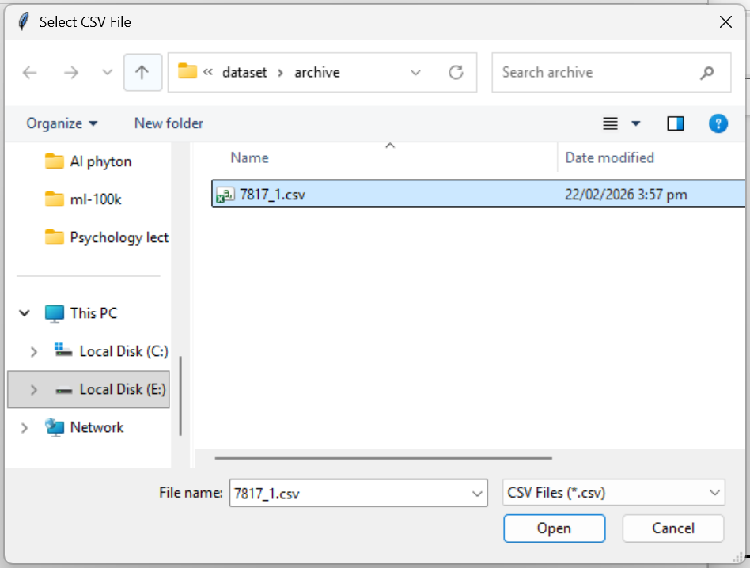

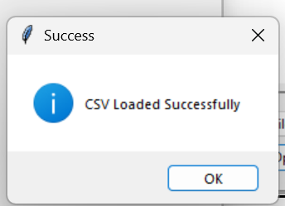

SELECT RECOMMEND PRODUCTS:



TYPE AI AMAZON PRODUCT:
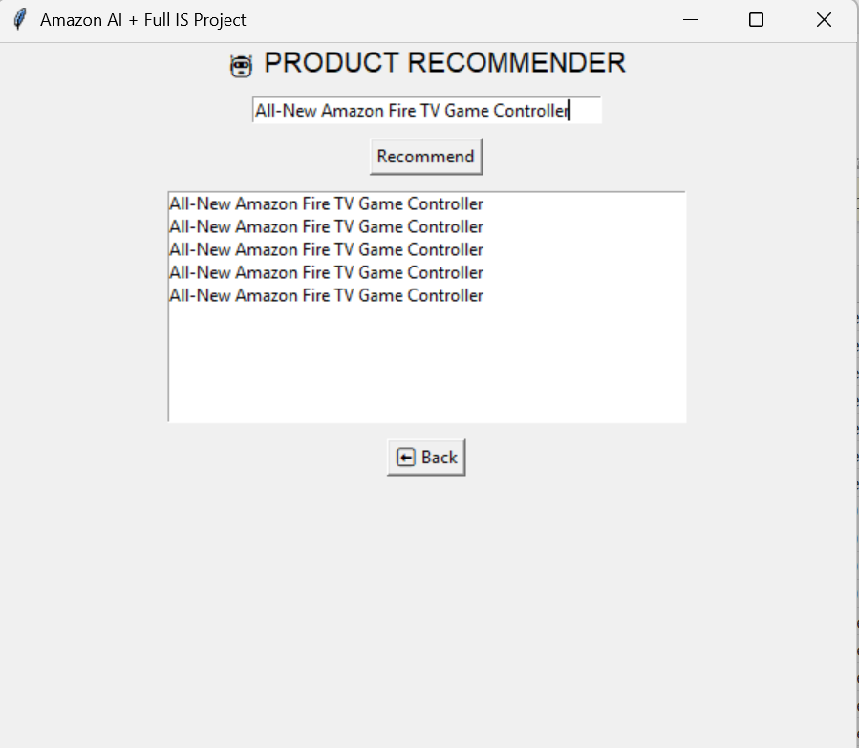

SELECT SECURITY PANEL:



SECURITY DASHBOARD:

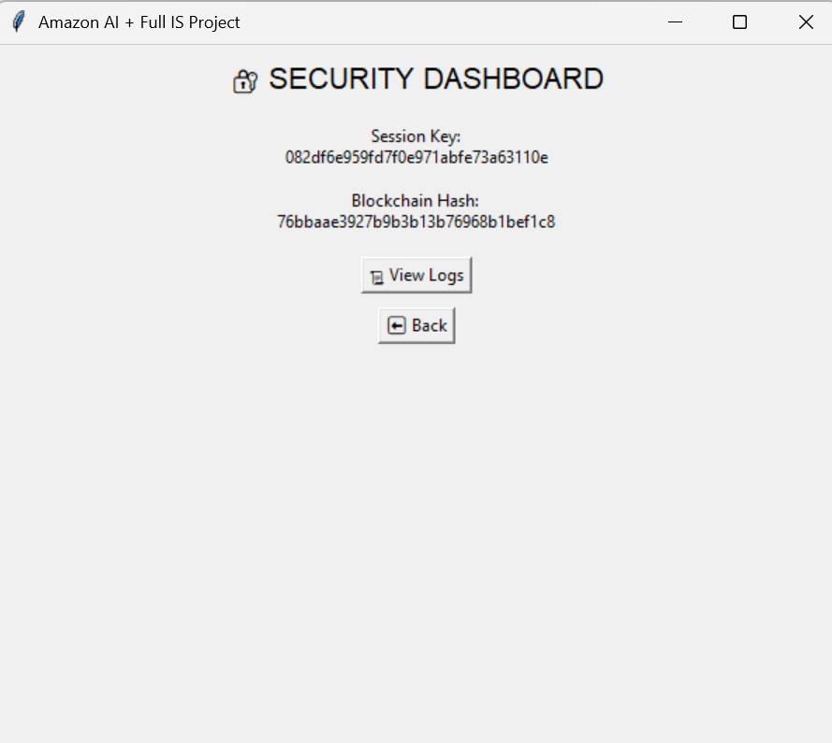

SELECT “VIEW LOGS” FROM SECURITY DASHBOARD:


“SECURITY LOGS WILL BE SHOWN”
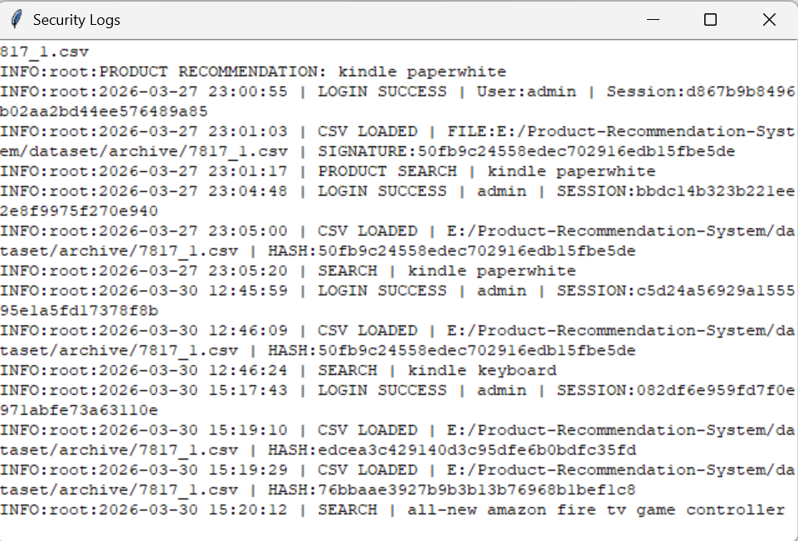

CLICK “LOGOUT” AND BACK TO LOGIN AREA:



